AWS Transit Gateway with Inter-Region Peering

Create VPC and Ec2 instance in N.Virginia

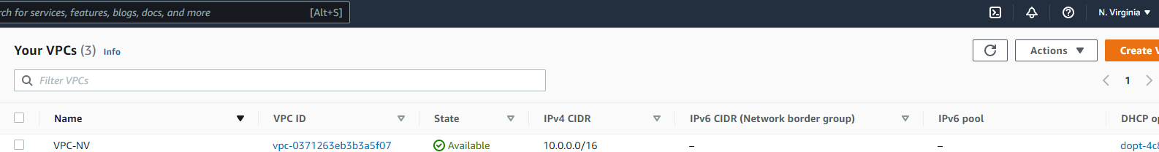

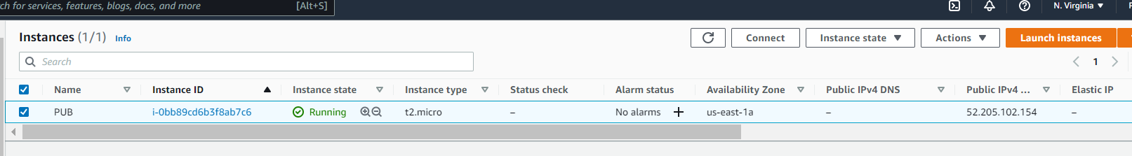

Create VPC and Ec2 instance in Oregon

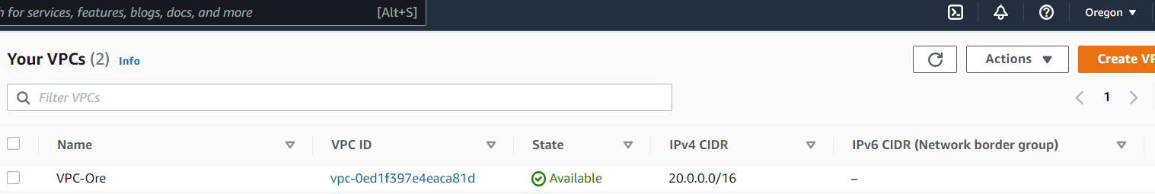

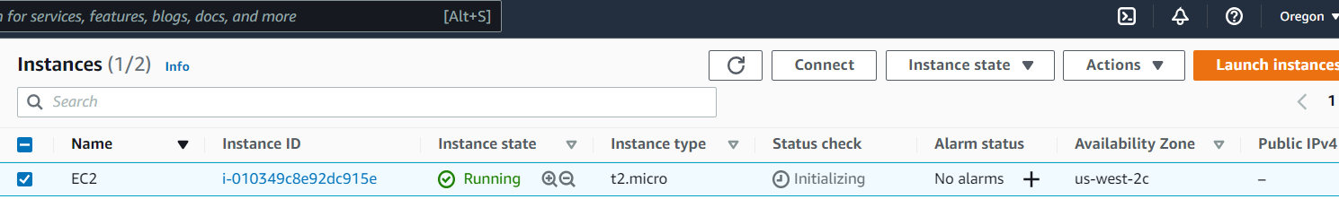

Create Transit Gateway in the both Regions

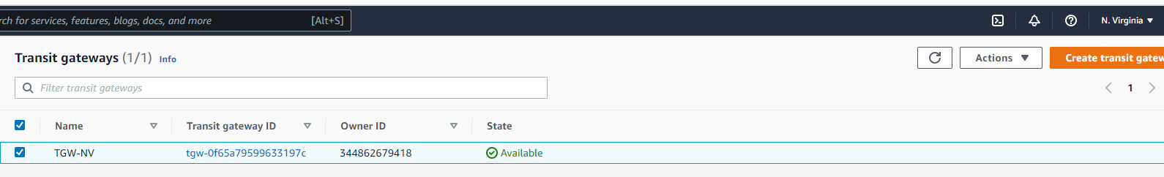

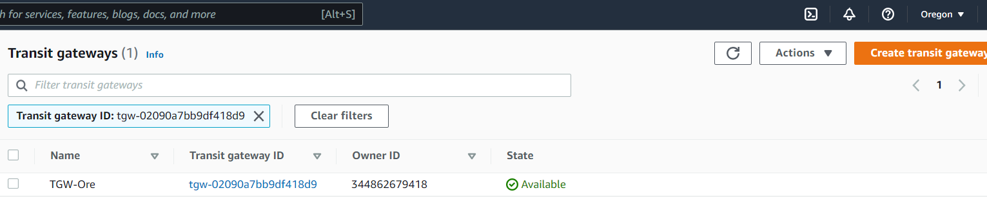

Attachment type choose Peering

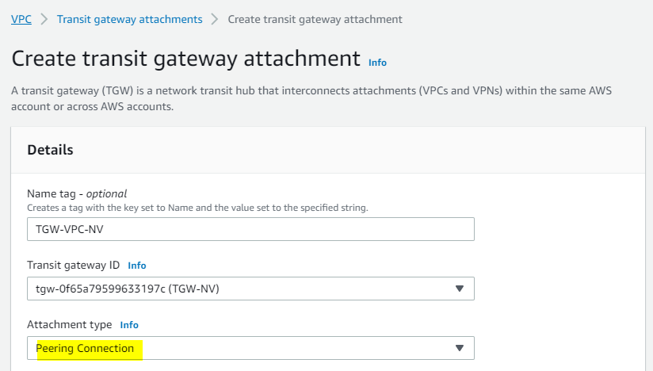

Select region Oregon and enter TGW ID of Oregon region

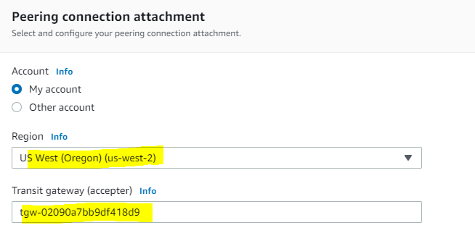

Switch to Oregon now you see **Pending for acceptance.** Click action and select acceptance

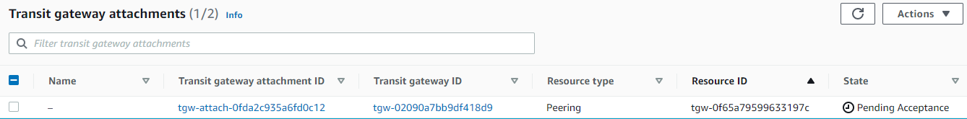

Now TGW attachment showing available in both region

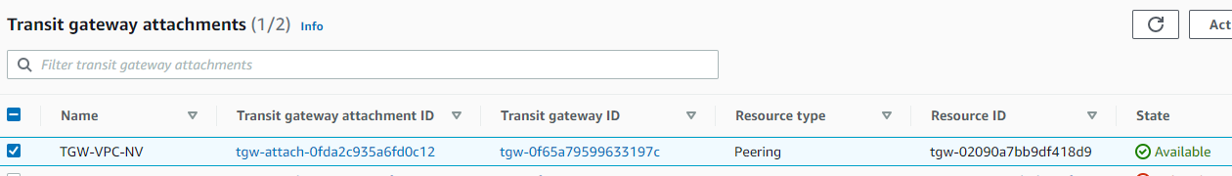



Create TGW RT in both region

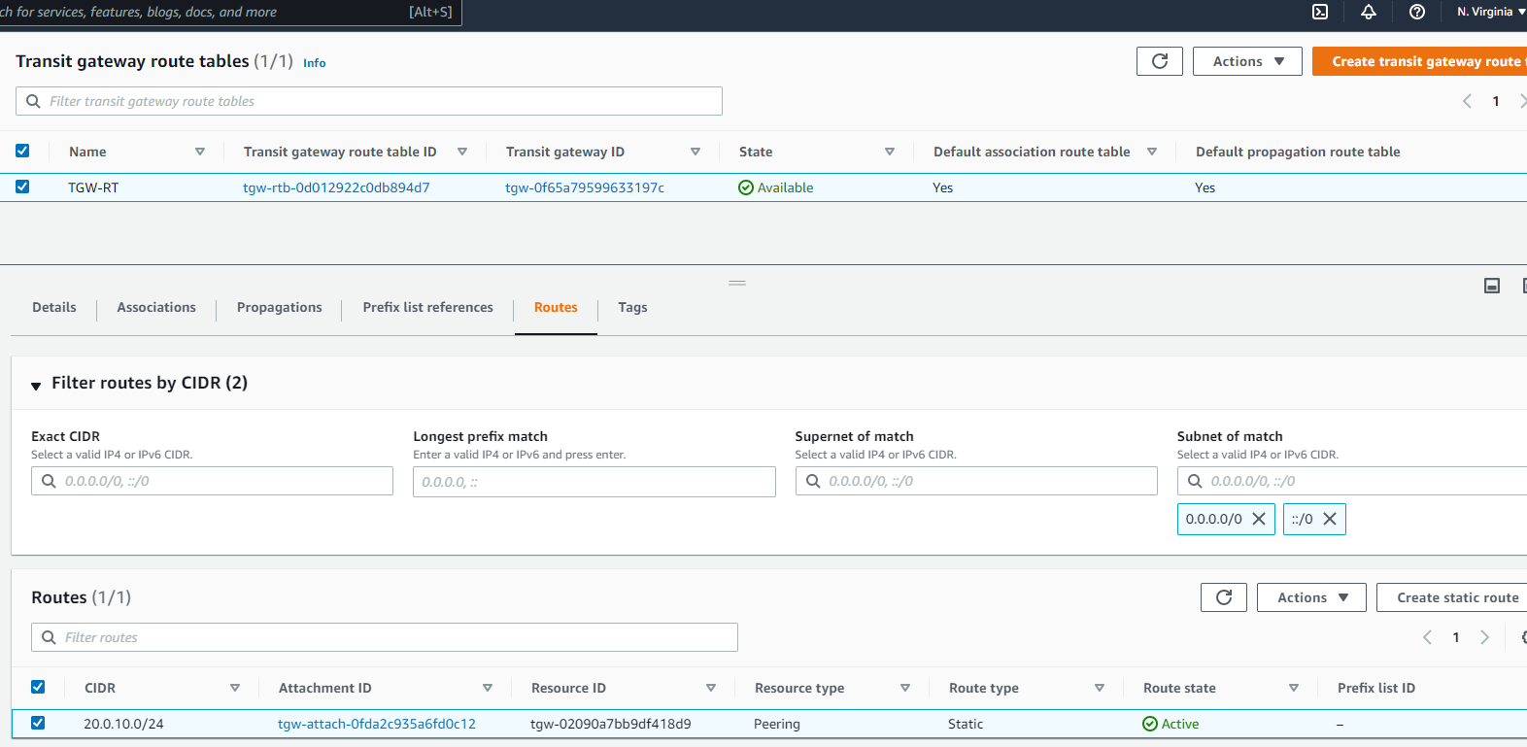

Create TGW attachment for VPC in both region

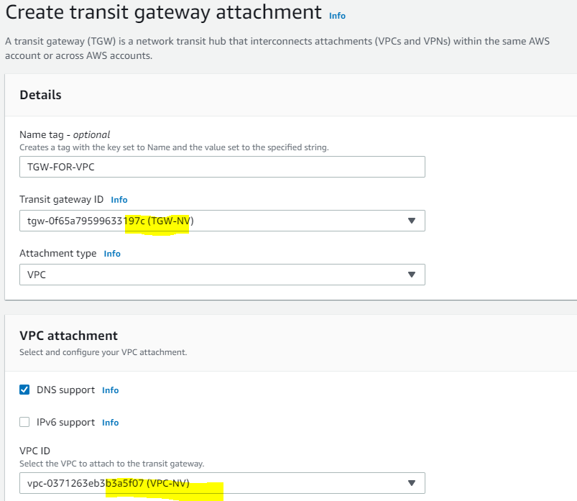

Now it time to add route entry in both VPC routes

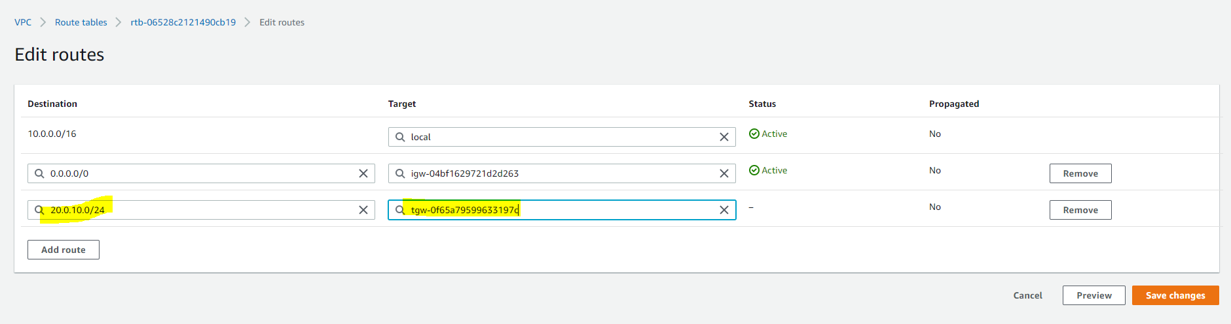

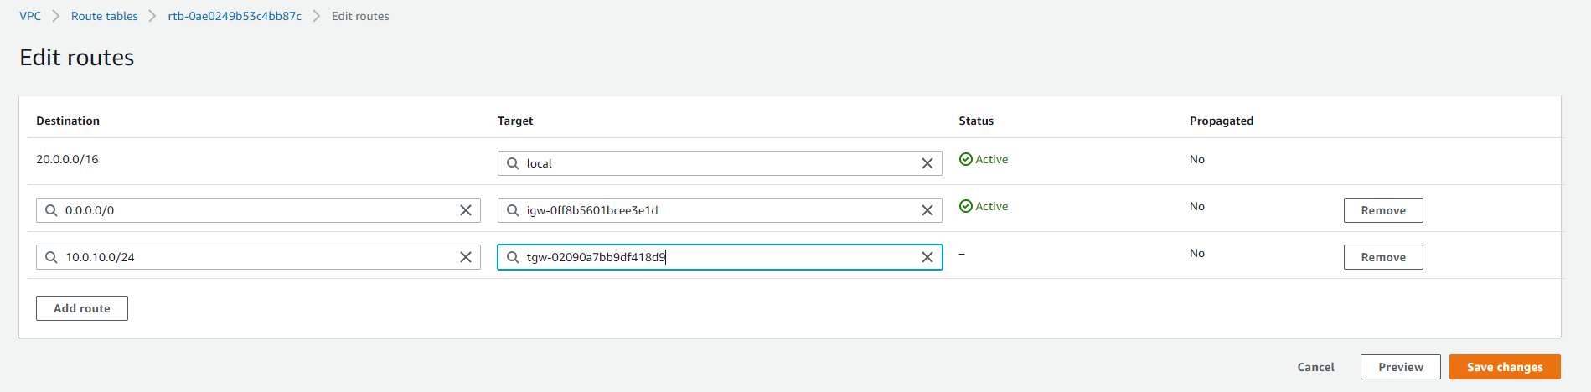

Ping connectivity is happening

From NV to Oregon

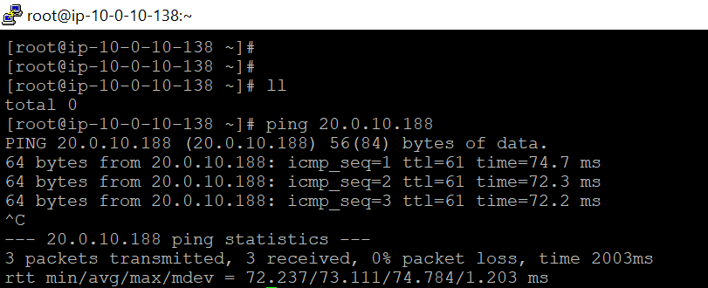

From Oregon to NV

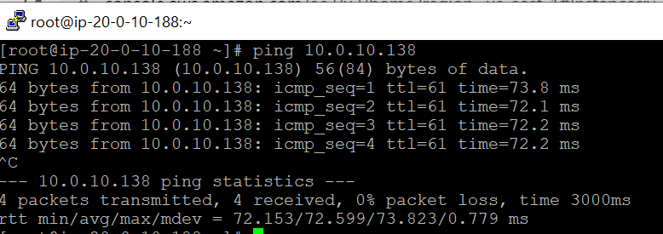

Able to take ssh from NV to oregon

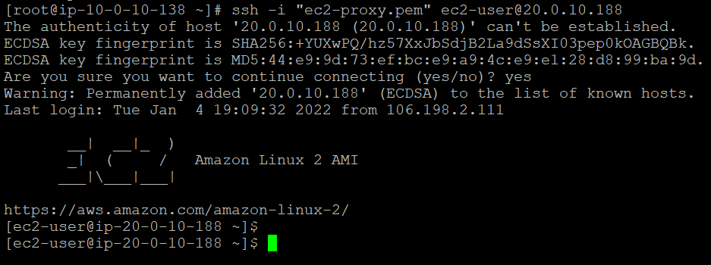

From Oregon to NV

